**WEEK-2**

(Implemented in Eclipse )

**1)Mockito**

Created a Maven project named MockitoDemo in Eclipse and added JUnit 5 and Mockito dependencies in the pom.xml to enable unit testing and mocking.

pom.xml

<projectxmlns="http://maven.apache.org/POM/4.0.0"xmlns:xsi="http://www.w3.org/2001/XMLSchema-instance"xsi:schemaLocation="http://maven.apache.org/POM/4.0.0 https://maven.apache.org/xsd/maven-4.0.0.xsd">

<modelVersion>4.0.0</modelVersion>

<groupId>com.example</groupId>

<artifactId>JUnitDemo</artifactId>

<version>0.0.1-SNAPSHOT</version>

<dependencies>

<dependency>

<groupId>junit</groupId>

<artifactId>junit</artifactId>

<version>4.13.2</version>

<scope>test</scope>

</dependency>

</dependencies>

</project>

Exercise 1:Mocking and Stubbing:

1. Create a mock object for the external API.

ExternalApi.java (Interface)

**publicinterface**ExternalApi {

String getData();

}

1. Stub the methods to return predefined values.

MyService.java

**publicclass**MyService {

**private**ExternalApiapi;

**public**MyService(ExternalApiapi) {

**this**.api = api;

}

**public**StringfetchData() {

**return**api.getData();

}

}

1. Write a test case that uses the mock object.

MyServiceTest.java

**importstatic**org.mockito.Mockito.*;

**importstatic**org.junit.jupiter.api.Assertions.*;

**import**org.junit.jupiter.api.Test;

**import**org.mockito.Mockito;

**publicclass**MyServiceTest {

@Test

**publicvoid**testExternalApi() {

// Step 1: Mock the ExternalApi

ExternalApimockApi = Mockito.*mock*(ExternalApi.**class**);

// Step 2: Stub its method

*when*(mockApi.getData()).thenReturn("Mock Data");

// Step 3: Use the mock in the service

MyServiceservice = **new**MyService(mockApi);

String result = service.fetchData();

// Step 4: Assert result

*assertEquals*("Mock Data", result);

}

}

**Output:**

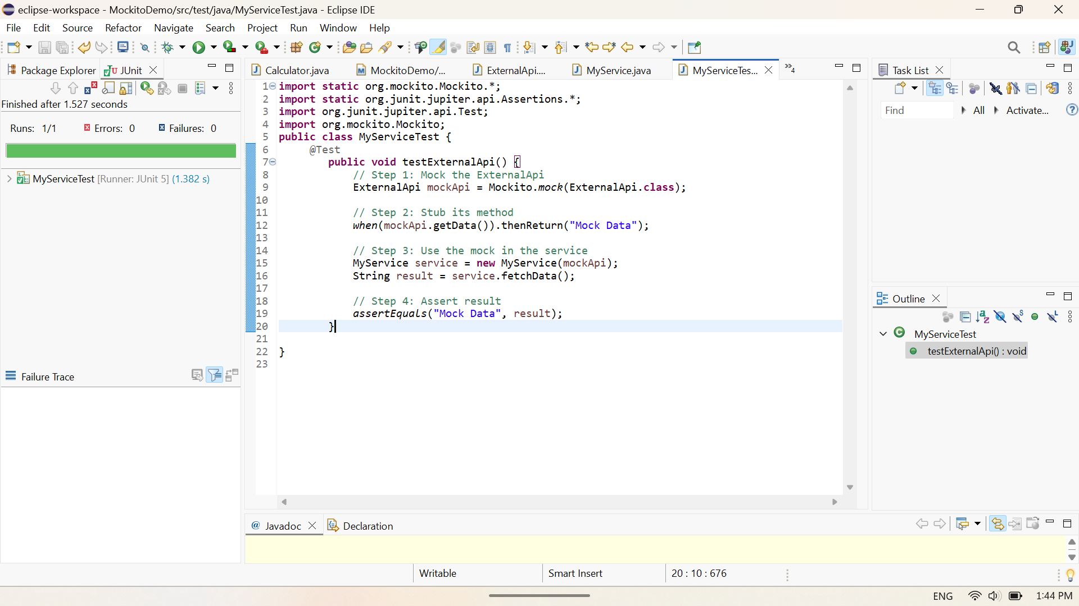

Exercise 2: Verifying Interactions:

MyServiceTest2.java

**importstatic**org.mockito.Mockito.*;

**importstatic**org.junit.jupiter.api.Assertions.*;

**import**org.junit.jupiter.api.Test;

**import**org.mockito.Mockito;

**publicclass** MyServiceTest2 {

@Test

**publicvoid**testVerifyInteraction() {

ExternalApimockApi = Mockito.*mock*(ExternalApi.**class**);

MyServiceservice = **new**MyService(mockApi);

// Call the method

service.fetchData();

// Verify that getData() was called

*verify*(mockApi).getData();

}

}

**Output:**

